**Activation of Beta-galactosidase gene in transformed *E.coli***

1. **Transformation**
2. **Definition:** genetic makeup of a cell is changed by **introduction of DNA from the surrounding environment.**

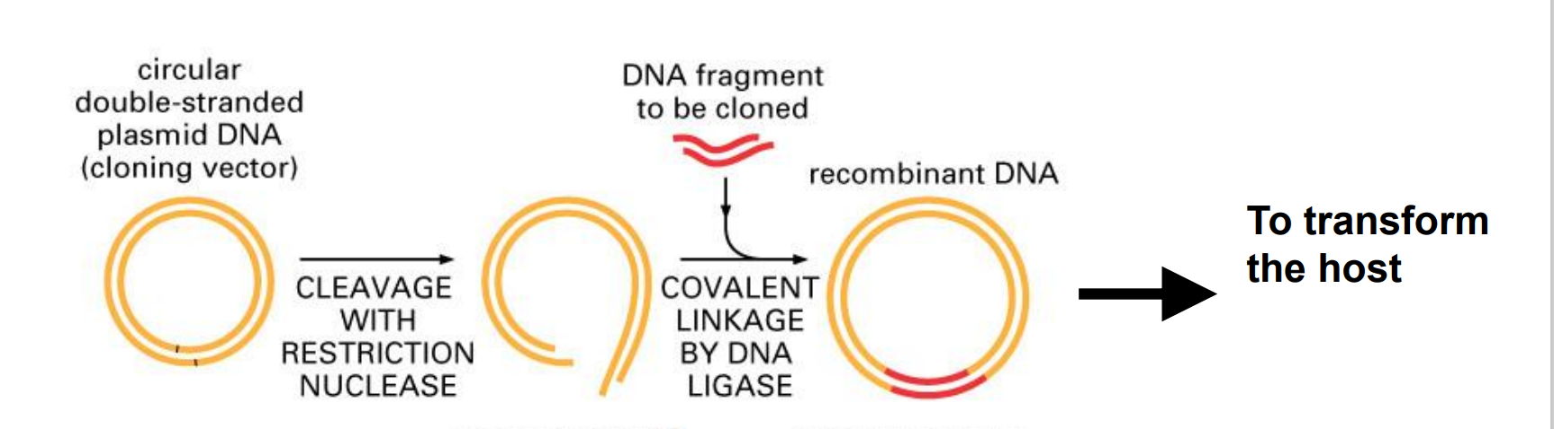

1. **Plasmid/Cloning Vector (pUC19)**
2. **Definition of Vector:** plasmids constructed for cloning DNA)
3. **Goal:** carries the lac promoter and the missing part of the Z gene introduced into DH5α by chemical transformation, **active beta-galactosidase is regenerated by a-complementation and the bacteria becomes Lac+**
4. **Contain**
5. Contain a **genetic marker** for selection, e.g. Ampicillin resistance gene.
6. Ability to **promote autonomous replication.**
7. Carries a short segment of E. coli DNA that contains the regulatory sequences and the coding information for the ß-galactosidase gene (lacZ).
8. **Unique restriction sites** to facilitate cloning of **insert DNA**, i.e. Multiple Cloning Site (MCS).

**Ps:** Embedded in this cloning region is a polycloning site that does not disrupt the reading frame

1. **Function**

1) will **allow gene activation by lactose or IPTG and the expression of the β-galactosidase activity**.(whether be inserted)

2) will **protect the bacteria in the presence of ampicillin**(whether take in)

3) allow the plasmid to **duplicate itself** during mitosis and the information it carries will be passed onto future generations of DH5α.

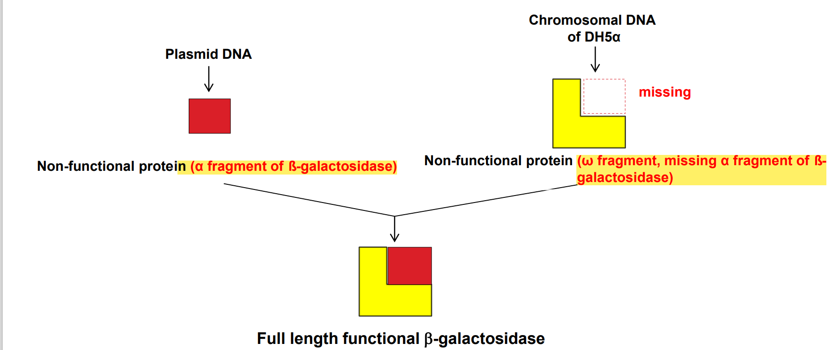

1. **Component Bacteria**
2. **Preparation**

* **process**
* **0.1 M CaCl2** is traditionally used to prepare the competent cells.

---alters t**he permeability of the cell membrane.**

* **Ice-cold CaCl2 treatment**

--- cell **becomes competent**

* **Heat shock treatment**

--- Cell **uptakes exogenous DNA**

* **theory**
* **Ca2+ interacts with the negatively charged** phospholipids heads of the cell membrane, creating an **electrostatically neutral situation**
* **Lowering the temperature** stabilizes the membrane, **making the negatively charged phosphates easier to shield**
* **heat shock creates a temperature imbalance** and thus a current, which helps get the DNA into the cell

1. ***E. coli***
2. **property**: Gram-negative, rod-shaped bacterium, support the replication of DNA plasmids
3. **DH5α:**
4. **Bacterial restriction** modification systems have been removed.
5. **Endonuclease** (restriction enzymes) activity has been mutated to **increase plasmid DNA yields.**
6. **DNA recombination systems** are modified to **prevent re-arrangements.**
7. **Part of the Z gene coding** for the amino terminal (α fragment) of ßgalactosidase has been **deleted** and it does **not exhibit any ß-galactosidase activity (Lac- ) because the enzyme is defective.**
8. **Galactosidase gene expression**
9. **Galactosidase Gene**

* The structural genes **(lac Z, Y and A)** encoding these enzymes
* the gene **(lac I)** that codes for a repressor protein and the promoter-operator elements constitute a regulatory unit called the lac operon.

1. **ITPG:**

A. induce the expression of galactosidase

B. the enzymatic activity can be increased greatly

1. **X Gal**

β-gal enzyme will cleave the colorless X-Gal and form an insoluble **bright blue precipitate,**

1. **Function of Beta-Galactosidase**

cut lactose molecules into glucose and galactose

1. **Materials**

Supplies:

▪ pUC19, concentration is 20 ng/ul in TE buffer

▪ DH5α competent bacteria

▪ dd H2O

▪ Luria-Bertani (LB) broth media (bacterial media which contain Tryptone

10 g, NaCl 10 g, Yeast Extract 5 g in 1 L H2O)

▪ LB plates with 20 ug/ml X-gal and 50 ug/ml IPTG

▪ LB plates with 100 ug/ml ampicillin, 20 ug/ml X-gal and 50 ug/ml IPTG

Note: LB broth and LB plate, is liquid and solidified media, respectively, for

culturing bacteria.

**Equipment:**

▪ Eppendorf refrigerated table-top centrifuge

▪ Sterile plastic centrifuge tubes, 15 ml and 50 ml

▪ Microfuge and sterile 1.5 ml plastic centrifuge tubes

▪ 200ul PCR plastic tubes

▪ Incubator and water baths set at 37oC

▪ Water bathes set at 42oC

▪ Racks for 1.5 ml tubes

▪ Ice buckets

▪ Pipetman P20, 200 and 1000

1. **Procedure**

1. Before the practical session, **DH5α cells cultured in LB-broth** are grown to

**mid-log phase and chilled on ice.**

2. Place about **40 ml of the bacterial culture in a sterile 50 ml centrifuge tube**

**and spin 4000 r.p.m.(revolution per minute)** for 5 minutes at 4oC in a

Eppendorf table top centrifuge.

3. **Pour out the supernatant**. Use Pipetman P 1000 to remove the media

4. **Add 4 ml of ice-cold sterile 0.1 M CaCl2** to the tube. Gently pipet to

**resuspend** the pellet.

5. **Incubate th**e bacterial suspension **on ice** for 10 minutes.

6. **Centrifuge** as Step 2 to collect the bacteria. Then Use Pipetman P 1000 to

**remove the supernatant.**

7. **Add 0.4 ml of ice-cold sterile 0.1 M CaCl2** to the tube. Gently pipet to

**resuspend** the pellet. Keep the competent bacteria on ice.

8. Prepare three 1.5 ml microfuge tubes and have them pre-chilled in ice. Set

up the following reactions (a, b, c) and label the tubes accordingly:

**(a) 100μl DH5α competent bacteria**

**(b) 100μl of 0.1 M CaCl2 + 2.5 ul plasmid solution**

**(c) 100μl DH5α competent bacteria + 2.5 ul plasmid solution**

**Tap the tubes for several times to mix the content.**

9. **Incubate** the tubes for 20 minutes **on ice.**

10.Place the tubes in water bath at **42C for 45 seconds (**heat shock induction).

11.Immediately **put tubes on ice for at least 3 minutes.**

12.Then **add** 1 ml room temperature **LB liquid media** to each tube. S**hake tubes**

at 225 rpm at 37C for at least 60 minutes to recover the bacteria.

13. **Gently spread** the bacterial suspensions after incubation on the pre-made using cell spreader. Afte**r drying the plate surface, close the dish** and label every plate lid with group number and sample number.

**a-XI-LB: 50 μl of (a) on LB plate with X-gal and IPTG**

**a-XI-A: 50 μl of (a) on LB plate with ampicillin, X-gal and IPTG**

**b-XI-A: 50 μl of (b) on LB plate with ampicillin, X-gal and IPTG**

**c-XI-A: 50μl of (c) on LB plate with ampicillin, X-gal and IPTG**

14. store them at 4oC until next week for your observation.

15.One week later, check the results of your sets of transformation. Count the number of colonies in each plate and mark down their color on the experimental datasheet.